DEVELOPING A DATA MANAGEMENT SYSTEM FOR THE NATIONAL BANANA RESEARCH PROGRAMME (NBRP), UGANDA

NAIROBI VISIT REPORT BY RWAKATUNGU ALLAN AND KISINGO HUSSEIN

1. Introduction

As a component of the Project that’s developing a data management system for the National Banana Research Programme (NBRP), Uganda, a two-week visit was undertaken by Rwakatungu Allan (Research assistant, National Banana Research Programme) and Kisingo Hussein (Data manager, International Institute of Tropical Agriculture) to The Research Support Unit of The International Centre for Research in Agro-Forestry (ICRAF) 5th to 15th July 2004. ICRAF staff Muraya Peter has made major strides towards a data management system which handles a wide range of study and data types, i.e. through conceptualizing and developing a software tool known as Logbook. It was this tool the above persons had gone to familiarize themselves with

The major aims of this visit were to
- Iron out problems they’ve been facing since they were introduced to by Muraya Peter when he visited The National Banana Research Programme in May 2004
- Get further training in the concepts of logbook model
- Get training in the data manipulation using Microsoft Access , the backbone of the logbook database
- Get training on how to associate data protocols to data sets

.
2. Visit activities

  - . Review of progress made by Rwakatungu Allan and Hussein Kisingo

The first few days were spent reviewing the progress made by Hussein and Allan on logbook since Muraya Peter had visited Kawanda in May 2004.
1.1.1 Allan’s logbook database: Allan has been maintaining a logbook database for the Rockefeller funded Fertilizer trial in Masaka and this was reviewed. A few things were noted about the database
- The use of data _ type in the orientation of the excel worksheet. It was pointed out to Allan that the row above the measurement _name is for long descriptions
- There should be no missing value in the orientation as this causes several errors when loading datasets into logbook.
- Allan was encouraged to use short value labels as this were easer to handle when it came to data analysis

1.1.2 Hussein’s logbook database: Hussein had been introduced to logbook earlier in 2000 and he had some logbook compliant datasets he had maintained from that time.
We attempted to load this datasets into logbook

1.2. Data Publishing

Muraya Peter introduced Allan and Hussein to a new concept he had introduced into the logbook model, data publishing.
The better part of the days spent at ICRAF were spent learning about the concepts of data publishing and preparing data sets and protocols for data publishing .

1.2.2. Data publishing concept explained using a case study of the National Banana Research Programme, Kawanda (As presented to Richard Coe, Principal Statistician ICRAF)
A good data management system = Efficiency +Preservation + Quality
Efficiency: This means that when a user is looking for a dataset he is able to find it quickly and easily.
Preservation: This means that the life cycle of a dataset is preserved longer when it is well managed. Two years from now? Five years from now? Ten years from now? A well managed dataset should be relevant and understandable after a period of time.
Quality: A quality dataset is one devoid of errors

What was the data management situation in Kawanda before the data management project started?
Efficiency: Data files were scattered all over the National Banana Research Programme computers. Anyone looking for a dataset would have to visit several scientists, some of whom would not be present and others who would have no idea were the datasets were.
The data that was available with the data managers was arranged people-wise. There was no integration of datasets.
Preservation: Datasets had no naming convections whatsoever. Variable labels depended on who had worked on the datasets. Understanding a dataset that had been collected e few years earlier was difficult, even by the owner of the dataset
Quality: Critical missing values that was necessary for using a dataset. Double entry, Missing datasets, Out of range values etc. This were the norm rather than the exceptions

What is the situation now?
There has been an attempt to consolidate data files over the last year from different scientists and these are now available on a single CD. The datasets are now arranged Project wise rather than people-wise ensuring a logical integration between the various datasets. However this has been done only for a few Projects emphasizing DFID and Rockefeller funded Projects.
The thinking is that logbook can be used to ensure further the quality and integration of the datasets collected by the National Banana Research Programme.

Use of logbook so far
Peters experience in Uganda
In May 2004, Peter Muraya developer of logbook visited Kawanda. He introduced logbook to the Kawanda data managers. He spent about a week loading datasets from one project, the enhanced Plant Nutrition Trial under the Integrated Pest Management
How many datasets did he load? 4 data files in a week

Allan’s experience with fertilizer trail database
Allan has been maintaining a logbook database for the fertilizer trial in Masaka. The project is on going, started in December 2003.
These are some of the interesting highlights of managing this data using logbook
- Some critical values were missing from some datasets. For instance, in the weevil damage datasets some plant numbers were missing. This was detected early using logbook as this value were critical in integrating this datasets with the others including soils and growth parameters
- Some values were unrealistic. In the baseline data some values were entered as being collected from the second ratton. This was detected by logbook from the tree structure it built

How many datasets has he loaded? 5 data files in two months

Yusuf s emerging problem
Yusuf is attempting to load all the old data files in the DFID CPP funded projects , Rockefeller funded projects and later moving on to projects.
We did a file count in Nairobi. 690 files to make logbook compliant for the DFID and Rockefeller funded projects only. And this are just excel files. There are other files; analysis files (SAS and SPSS), reports, pictures etc.
Here is an estimate
Let’s assume Yusuf uses 2 hours a day to archive the old datasets
Educated estimates say he will take approximately 2 hours to make 1 excel workbook logbook complaint and successfully load it into the logbook database without encountering errors
He has 690 files to work
There it would take him
690 files x 2 hours per files /2 hours per day =690 days to complete the job

The Publishing Approach
Below are the steps
- Use extensible markup language (XML) to tag Protocol files that give explanations about the datasets
- Give file properties to ANY data file format associated with the study
- Load the above into logbook
- Publish from logbook hyper text markup (htm) files which are searchable

If it’s sounding complex, let’s try and demystify all terms that are in the procedure

Consider a Study, for example “The effect of enhanced plant nutrition as a management option of banana leaf spot diseases for highland bananas”
Available is a protocol that describes the study and explains the data that was collected (figure 1)

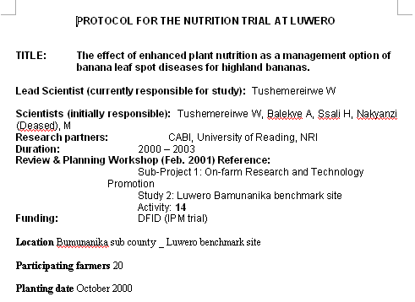
(Figure 1)

Also available are datasets collected
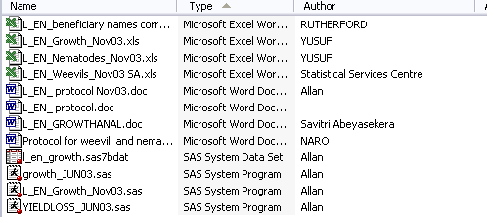

Step 1
Use extensible markup language (XML) to tag Protocol files that give explanations about the datasets
Using Microsoft word 2003 its possible to tag a document using XML so that a Programme can read it and tell which is the title of the study , who are the authors ,when the study was done etc using a defines xml schema (Interprets the xml into a format logical to you)

Step 2
Give file properties to ANY data file format associated with the study

Right click a file in a folder.
On the resultant menu click the summary tab
Give the file properties as follows
- Title: A unique identifier for the file plus the title of the file contents
- Subject: A short name for the study
- Category of the data file , in this case the file is under Biological data category

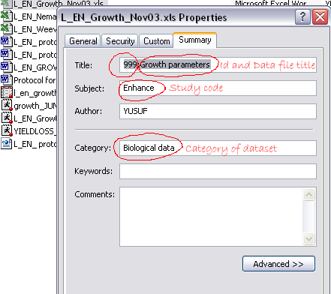

Step 3
Load the above into logbook
Load the files into logbook using the Update database using file properties and Update database using XML properties
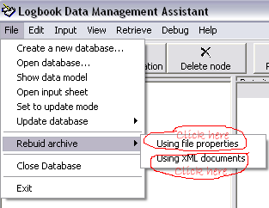

The protocol and file properties are imported and integrated by the database

Step 4
Publish from logbook hyper text markup (htm) files which are searchable
Publish from logbook hyper text markup files (htm) using the Retrieve data for publishing command of the logbook assistant
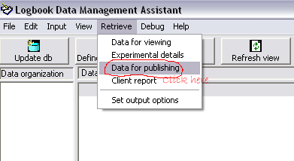

Here are the results of publishing

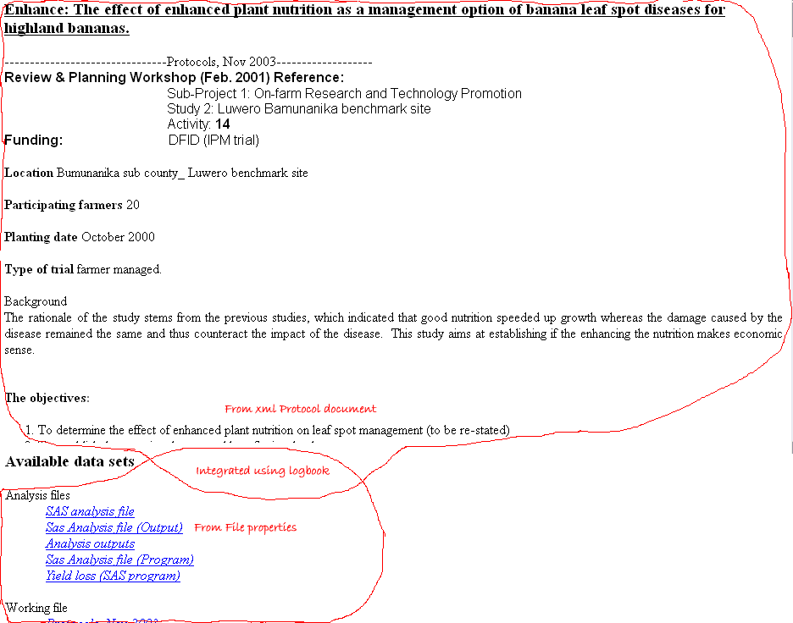

We have a hyper text markup (htm) file with the contents of the protocol at the top and links to files associated to research protocol at the bottom. Clicking on a link opens the associated data file.
Note that there not only excel files that are attached. SAS analysis and output files, SPSS files, other protocols …any file can be associated with a protocol and clicking on the link opens the file

Is that it? What’s the big deal? You ask

Having our protocol files in this format serves one major advantage.
Using windows full text indexing service it’s possible to search the contents of the protocol words.
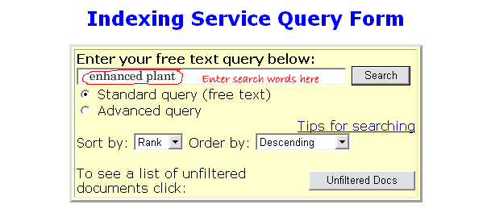For example, if you typing the words enhanced plant into the index window would yield “The effect of enhanced plant nutrition as a management option of banana leaf spot diseases for highland bananas” as one of the results
Clicking on it would open our hyper text markup file (htm) with the protocol and clicking on the links would open the associated files

Hussein and Allan’s experience using this approach
Using this approach Hussein published 150 files from an International Institute of Tropical Agriculture (IITA) project in one day
Allan was able to publish 193 files from the IPM project CD archive in 2 days

Revisiting the original problem
Recall our data management problem
Data management = Efficiency + Preservation + Quality
The “old” logbook approach which we called “logbook +” ensured all the above, comprising on time taken to make files logbook and load them into the database without encountering stop errors
On the other hand the “new” logbook which we called “logbook – “ is a data management tool that ensures efficiency in finding and retrieving datasets and preservation as reading the meta data can help understand the attached files even after a long time ,but compromises on quality. With “logbook –“the nothing is done to the data itself. If there were errors, they will remain.

The conclusion
Experiences by Allan, Hussein and Yusuf show that “logbook +” is very appropriate with current work. Using logbook errors of data entry are nipped at the bud, integration of the different datasets is ensured and the powers of retrieving and manipulating data using Microsoft Access queries can be harnessed at the time of data analysis.
However, for old datasets some of which have already been analyzed, reports and papers written etc, what are the benefits of ensuring maximum data quality? Why spend so much time cleaning up old data files? In comes logbook - . By dwelling less on quality and focusing more on efficiency it ensures that more of the old data files are archived and can be found easily leaving more time for the nitty gritty of ensuring quality data to current files that of major interest to the projects

Draw backs of the publishing approach
The publishing approach has other draw backs
- It requires Microsoft Office 2003 which has in built support for extensible mark up language (XML). Both IITA and NBRP do not have this software and so are unable to publish data files
- The technique is still being refined. There still some things that need to be done on the programme amongst which is having links to related protocols. For example while reading the enhanced nutrition protocol it would be nice not only to have links to data files from the study but to protocols of related studies like the evaluation and evaluation trials which were all funded by DFID.

What next

Allan:
- Spread the word of logbook publishing to Mulumba Yusuf who did not take the trip to Nairobi
- Use the publishing technique to work on the banana bacterial wilt database. Allan is assisting the banana bacterial wilt task force to design and implement there GIS database. Some of the data from this database will be put on the National Banana Research Programme website for public consumption. Using one tool, the logbook assistant, Allan will be able to both have data of assured quality and integration at the same time quickly publishing hyper text markup (htm) files. With little editing this can quickly upload to the website. Exciting!!!
- Hussein will now find the time to archive the old IITA files. There locations are known but there had been no system to quickly centralize them, now there is.
- Peter will continue to improve on the programme

1.3 Data manipulation

Hussein and Allan spent the last few days learning how to manipulate data from Access. They were showed how to use the query design window and how using cross tab queries, and structured query language (SQL).

