DEVELOPING A DATA MANAGEMENT SYSTEM FOR THE NATIONAL BANANA RESEARCH PROGRAMME (NBRP), UGANDA
Progress Report: January to December 2004

1. Background and Objectives
1.1 The National Banana Research Programme (NBRP) in Uganda undertakes a wide range of research projects, most of which generate large volumes of data. Therefore, there is a need to have a system in place for managing the data effectively, avoiding duplication of effort in data collection and computerisation work across the numerous studies undertaken, and ensuring ready access to comprehensible and usable data.

Such a system will
(i) provide the means to get data in,
(ii) ensure data are of good quality,
(iii) hold every observation and the associated “metadata” (What? When? Where? Who? Why and How? information, and other notes),
(iv) allow these to be retrieved for scrutiny,
(v) allow analysis datasets to be selected and synthesized from the input files.

ICRAF staffs have already made major strides towards a data management system which handles a wide range of study and data types, i.e. through conceptualizing and developing a software tool known as Logbook. It therefore seems appropriate to use Logbook to incorporate all existing NBRP data and enable a flexible system for capturing information from all NBRP’s data collection activities.

1.2 SSC funded by DFID Project (R8301) supported initial activities to help in the development of a data management system. The outputs of the project were

(a) An Archive at the National Agricultural Research Organisation (NARO) in Uganda, of all raw data, meta-data and study protocols, as well as reports available by December 2003, for the CPP-funded cluster of banana projects, i.e. projects R7567 (IPM), R7529 (BSV) and R7972 (Weevils).

(b) Setting up guidelines and procedures, necessary for maintaining a good database management system, and documenting these in consultation with NBRP staff, with the work facilitated through staff training in basic principles of research data management.

- Developing and documenting an appropriate data management strategy for all NBRP research activities; this was accepted by NBRP staff and collaborators.

*outputs (b) and (c) are available at the National Banana Research Programme website at
http://www.banana.go.ug/pages/dtmngt.htm

1.3 The Rockefeller Foundation is funding a 2 year continuation of this project.
The overall objective is to develop a “Banana Logbook” – a flexible tool for management of research data within the Uganda National Banana Research Programme. It involves joint efforts between NBRP staff, the Research Support Unit at ICRAF in Nairobi, and the Statistical Services Centre (SSC) at the University of Reading in the U.K

Specific objectives to be achieved in years 1 and 2 of this project are given below. These objectives will lead to a Banana Logbook, developed in close collaboration with two key computing personnel, based at Kawanda Agricultural Research Institute, so as to ensure local ownership of the final product.

A second objective is capacity building for the computing personnel as well as for research scientists to help them to enhance the quality of their research outputs

Specific Objectives for Year 1:

1.3.1. Development and documentation of a Data Management Strategy for NBRP, in joint association with the on-going DFID-funded project (R8301) on archiving of data for the DFID-funded cluster of banana projects and associated training for NBRP research staff on basic principles of data validation and data management.

1.3.2. Organizing data from one banana project for input into Logbook and using this (a) to raise awareness amongst banana researchers of the potential benefits of the Logbook system for managing their research data, and (b) to provide training on the Excel data formats required for easy transfer of data into Logbook.

1.3.3. Further develop, modify, improve and pilot test the documentation for a “Banana Logbook”.

1.3.4. Hussein Kisingo (Data manager IITA) and Allan Rwakatungu (Research assistant, Biometrics, NBRP) locally trained to receive a Diploma in Information Systems Management, and a Certificate in Desktop Visual Basic, via evening and Saturday courses in Kampala

Specific Objectives for Year 2:

1.3.5 To achieve the final version of the “Banana Logbook” with appropriate training of key computing personnel and incorporating data from at least 5 banana research projects into the Banana Logbook.
2. Outline of activities
The activities started on 01 January 2004
2.1 Peter Muraya (ICRAF) visited the National Banana Research Programme in May 2004.
He spent a total 14 days in which he carried out the following tasks:

(1) Organized data from one of the banana projects for input to the Logbook. Integrated Pest Management (IPM) project data files were loaded into logbook to obtain a sample database that was used for demonstration in a subsequent training workshop.

(2) Raised awareness amongst banana researchers of the potential benefits of the Logbook for managing research data. This was done through a 2-day workshop entitled ‘Tools and methods for data management in the Uganda National Banana Research Program’. Rather than concentrate entirely on Logbook the sessions for this workshop were selected to deliver the following message: (a) Research data management is important for long-term data preservation, enhanced data quality, and efficient arrival at valid conclusions from raw data (b) Data management is not cheap, but there is always something you can afford to do now to advance your own personal practice (c) Putting your data into a Logbook database is a clear indicator that your data organization already meets some of the basic data management criteria – such as logical integration of data files.

(3)Provided training to banana researchers on the Excel formats required for easy transfer of data into Logbook. This training was provided in two instances: (a) during the preparation of data sets to construct the database from the IPM project data and (b) after the sensitization workshop when he held a data management ‘clinic’ with the key data handlers – Allan, Yusuf and Hussein – prepared and loaded data assets under his supervision.

(4) Contributed towards setting up a data management strategy for the NBRP. Savitri (SSC) had already developed a draft strategy. Muraya Peter, senior research management at Kawanda spent time after the workshop perusing the draft and reporting comments which were compiled into the final document.

2.2 Key personnel at Kawanda, Rwakatungu Allan (Research assistant, NBRP) and Kisingo Hussein (Data manager, IITA) continue to train in Information Technology (Networking and database development). This training will enable them to support NBRP in preparation and subsequent maintenance of the database management system.

1.3 Rwakatungu Allan and Kisingo Hussein visited ICRAF (Kenya) from 5th to 15th July 2004.
The major aims of this visit were to:
- Iron out some problems we have been facing since we were introduced to the Logbook by Muraya Peter when he visited the National Banana Research Programme.
- Get further training in the concepts of logbook model
- Acquire training in data manipulation using Microsoft Access , the backbone of the logbook database
- Obtain training on how to associate data protocols to data sets
Time was spent reviewing the progress Allan and Hussein had made towards building there own data logbooks and any problems and queries they had were worked out under the supervision of Muraya Peter.
A great deal of time was however spent being introduced and exploring a new feature on logbook called Publishing. (See appendix for details on data publishing)

1.4 The datasets in the archive have been prepared for data publishing. (See in appendix how datasets are prepared for publishing). The next stage is to obtain the latest version of logbook which Peter Muraya should send before the end of the year and data publishing can begin

1.5 Rwakatungu Allan has prepared excel files from two projects so far, the Rockefeller funded Masaka Fertilizer trial and the Banana Bacterial Wilt database, entered and maintained them in logbook.

1.6 The archive has been expanded to include data from the Rockefeller funded Improvement of banana marketing and utilization project , Economics of Soil Fertility Management in Banana Production trial in Masaka and DFID funded Promotion of improved IPM practices for banana diseases and pests in Uganda

3. Activities in the next year

3.1 Rwakatungu Allan and Kisingo Hussein complete publishing of datasets in the archive
3.2 Continue to add data into the archive, especially data generated from the Banana Bacterial Wilt activities.
3.2 Rwakatungu Allan and Kisingo Hussein visit ICRAF (Kenya) to further develop there skills in logbook publishing.
3.3 Cathy Garlick (SSC) visit Uganda to familiarize herself with logbook data publishing and incorporate it into the logbook manual. She will also consult with NBRP on there use of logbook to improve the documentation
3.4 Savitri visit Uganda to assist in writing the final project progress report.

Appendix
Logbook data publishing
- Why publish data
Those who have managed data know that there is a difference in how old datasets (this a datasets from which reports have already been written) and current datasets (datasets from which reports have not been written or those were data collection is own going) are used.
Logbook developers have taken this into account and recommended data publishing for old data sets.
Think about a data management system using the formula below:-
A good data management system = Efficiency +Preservation + Quality
Efficiency: This means that when a user is looking for a dataset he is able to find it quickly and easily.
Preservation: This means that the life cycle of a dataset is preserved longer when it is well managed. Two years from now? Five years from now? Ten years from now? A well managed dataset should be relevant and understandable after a period of time.
Quality: A quality dataset is one devoid of errors

Think about the attributes above in terms of old datasets and a current datasets.
For a current dataset, the owner is probably working on it and knows the dataset like the back of his hand. However data in its raw form usually has errors which require to be captured while they can be still corrected. What we are trying to say here is that for a current dataset, quality is probably the most important factor in determining how good a data management system is. The traditional logbook with its comprehensive relationship model that goes down to the minute detail of one data value is probably the right tool to use in such a situation.
However for old datasets efficiency of data retrieval is probably the most important factor in determining how good a data management system is. We are not saying that for old datasets, quality is not important. No. We assume that by the time a report was written , a paper published the data used was already of some quality , so the best way of storing it is not to concentrate on quality again , but on how this data can be found and reused again in future , hence the publishing approach. This approach to data management dwells less on the quality of data values in a dataset, but rather on how reports, data files, pictures etc generated in a project can be found and retrieved in the least amount of time.

2. The publishing process
Below are the steps
- Use extensible markup language (XML) to tag Protocol files that give explanations about the datasets
- Give file properties to ANY data file format associated with the study
- Load the above into logbook
- Publish from logbook hyper text markup language (html) files which are searchable

This above may sound complex, but let us try and demystify the procedure

Consider a Study, for example “The effect of enhanced plant nutrition as a management option of banana leaf spot diseases for highland bananas”
Available is a protocol that describes the study and explains the data that was collected (figure 1)

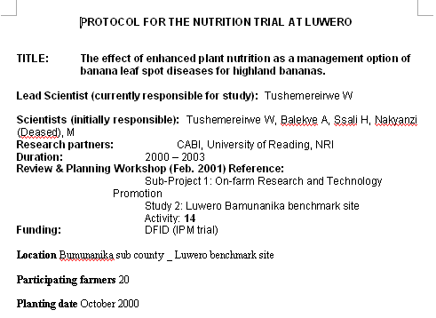
(Figure 1)

Also available are datasets collected

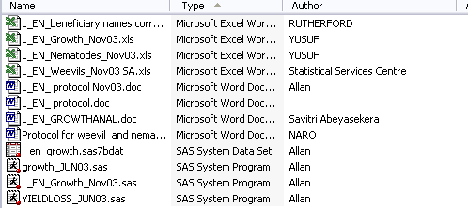

Step 1
Use extensible markup language (XML) to tag Protocol files that give explanations about the datasets
Using Microsoft Word 2003 it is possible to tag a document using XML so that a Programme can read it and tell which is the title of the study , who are the authors, when the study was done etc using a defined XML schema (Interprets the xml into an html format logical to you)

Step 2
Give file properties to ANY data file format associated with the study

Right click a file in a folder.
On the resultant menu click the summary tab
Give the file properties as follows
- Title: A unique identifier for the file plus the title of the file contents
- Subject: A short name for the study
- Category of the data file , in this case the file is under Biological data category

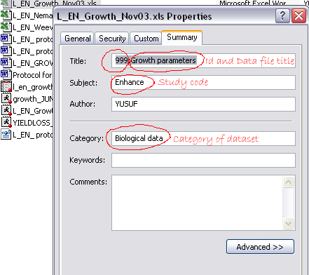

Step 3
Load the above into logbook
Load the files into logbook using the Update database using file properties and Update database using XML properties

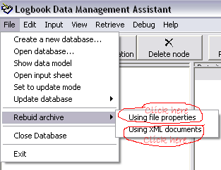

The protocol and file properties are imported and integrated by the database

Step 4
Publish from logbook hyper text markup (htm) files which are searchable
Publish from logbook hyper text markup files (htm) using the Retrieve - Data for publishing command of the logbook assistant

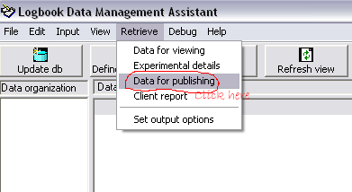

Below are the results of publishing

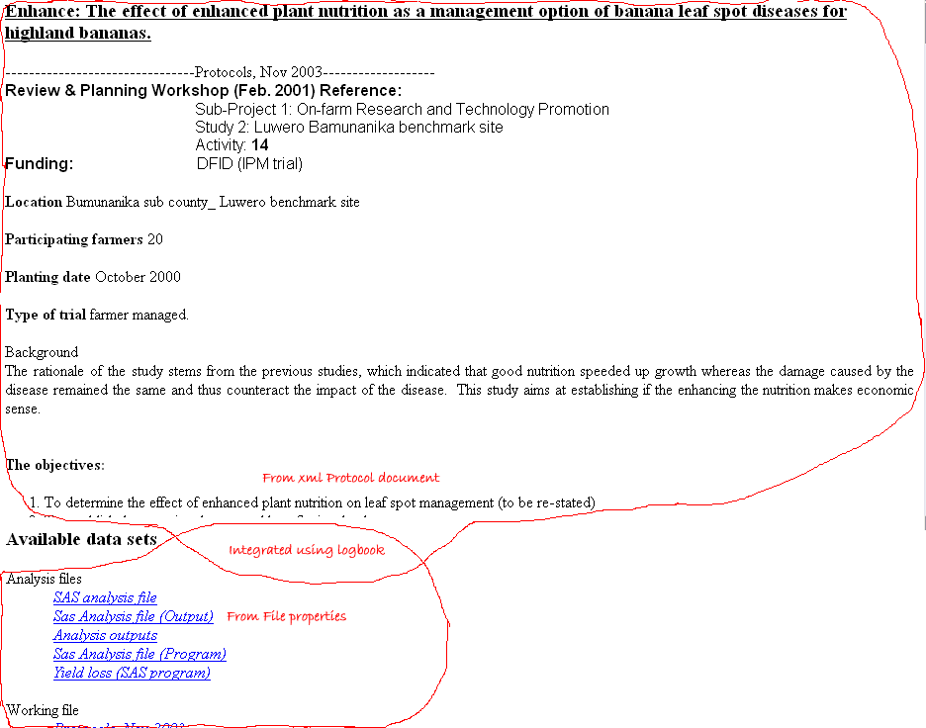

We have a hyper text markup (htm) file with the contents of the protocol at the top and links to files associated to research protocol at the bottom. Clicking on a link opens the associated data file.

Note that there not only excel files that are attached. SAS analysis and output files, SPSS files, other protocols …any file can be associated with a protocol and clicking on the link opens the file

Is that it? What’s the big deal? you ask

Having our protocol files in this format serves one major advantage.
Using windows Full Text Indexing service it’s possible to search the contents of the protocol text.
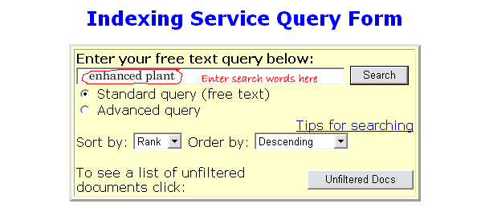For example, if you typing the words enhanced plant into the index window would yield “The effect of enhanced plant nutrition as a management option of banana leaf spot diseases for highland bananas” as one of the results.

Clicking on it would open our hyper text markup file (htm) with the protocol and clicking on the links would open the associated files

