Contents

1 Introduction 1

2 Status of 2010 Projects 1

2.1 Carbon Benefits Project (CBP) 1

2.1.1 The Data Management Protocol Manual 1

2.1.2 The Prototype 1

2.2 Sub-Saharan Africa Challenge Program (SSA CP) 2

2.2.1 Documenting Quefax 2

2.2.2 Compiling Baseline indicators 2

2.2.3 Summarizing M&E data 3

2.2.4 Supporting end-line survey 3

2.2.5 Compiling Biological data 3

2.3 Global Research Project 6 (GRP6) 4

2.3.1 Rapid cataloguing 4

2.3.2 Internet access 4

2.4 Investigations database (InvDB) 4

2.4.1 Research Management Systems (RMS) Model 5

2.4.2 Staff Performance Data Protocol 5

2.5 Research Methods Group (RMG) 6

2.5.1 The RDM policy 6

2.5.2 Ad hoc support services 6

3 Institutional Data Archive 7

3.1 The Tree Improvement Program 7

3.2 The East and Central Africa Regional Program 8

3.3 Alternatives to Slash and Burn in Forest Margins 9

3.4 Improved Fallows in Eastern Zambia 10

3.5 Soil Nutrients Management 10

3.6 Woodlots Research in Shinyanga, Tanzania 10

3.7 Lake Victoria Land Management Project 10

3.8 Southern Africa Regional Program 11

3.9 Western Kenya Integrated Ecosystem Project 12

4 The Logbook Toolbox 13

4.1 Binary code 13

4.2 Source code 13

4.3 Documentation 14

5 Appendices 16

5.1 Baseline Databases for the SSA-CP 16

# Introduction

The author estimated that it would take approximately 4 months to effectively document files and folders that hold work attributed to him, but for the purpose of a quick documentation that one would find useful if the author was run over by a bus, Tony Simons, Anja Gassner and I agreed that 5 days of work would suffice. This is the draft report based on a full backup of the author’s laptop that stored the bulk of his work. It is divided up into 3 chapters.

Chapter one reports on the status of the projects the author worked on in 2010, possibly for continuation by the successor. References to the addresses on the backup server are stated using styles such as this, ~\projects\CBP\Workshop\The Data Management Protocol.pptx. The tilde (~) denotes the root folder of the server, such as:-

\\172.28.0.238\sharedoudata\icraf\research methods group\peter muraya handover

Chapter two documents data that was handed over to the author by earlier departed ICRAF staff.

The last chapter documents the Logbook Toolbox that was used to design and implement all the data management protocols developed by the Research Methods Group

# Status of 2010 Projects

## Carbon Benefits Project (CBP)

The main focus of my work in CBP was ‘How to set up a Structured Data Management System’ for the project. Two outputs were planned: a protocol manual and a prototype.

### The Data Management Protocol Manual

The final version of the manual, also known as the DM protocol, was completed and submitted to the project coordinator and the grants information management office in early January this year. A copy is available at ~\projects\CBP\Documentation\work\Output 4- supporting data management-Final version.docx. The power point presentation (ppt) at ~\projects\CBP\Workshop\The Data Management Protocol.pptx complements the manual.

The manual provides details on the following protocols:

* Project-wide data sharing, useful during the project development
* Acquisition of complex data, developed by adapting the Quefax Method (see the SSA CP project)
* Integrating multiple data formats for efficient analysis & quality control

### The Prototype

The second output was a prototype to demonstrate the application of the DM protocols. The key features of the project-wide data sharing protocol are demonstrated by the website hosted at <http://researchrmg> and accessible from the ICRAF intranet. At ~\projects\CBP\Datasets\Allometry\work you will find a prototype to demonstrate how to integrate multiple data formats built with data from the Allometric equations work of Dietz at al.

The target audience for these protocols is the scientist developing the various measuring and monitoring protocols of carbon in complex landscapes: the organic soil carbon measurements, the greenhouse gas measurements etc. They were designed to ensure that complex data is managed efficiently, its quality assured and that the it is documented during the project rather than at the end. My concern is that this will not happen, because it will take more resources to apply these protocols than the project had planned. It took us two weeks to turn the masses of data generated by Dietz et al into an organized relational database; it would not take less for other datasets.

Henry, the CBP coordinator is planning to integrated datasets starting at a much higher level, i.e. rather than deal with the raw data, work with the semi-processed versions. The protocols would still be useful, but the researchers will have done most of the work that the protocols were designed to ease.

## Sub-Saharan Africa Challenge Program (SSA CP)

I lead the team that provided the cross-site data management support to SSA CP.

The following were my activities for 2010.

* Document the Quefax Method for Data Capture in large Surveys
* Compiling the Baseline indicators for all the Pilot Learning Sites (PLS)
* Summarizing the M&E data for all the SSA-CP sites
* Support to the End-of-project Impact Survey
* Compiling all the Biological data generated in 2010

His section reports the status of each activity, concerns, and estimates of the amount of time to fill the gaps.

### Documenting Quefax

The Quefax software (for ensuring data quality, efficiency and access) development was completed in 2009 and archived at ~\Quefax. The final version of the user manual was completed late last year, shared with the program coordination office of SSA CP at FARA and the grants information management unit of ICRAF. A copy is available at ~\projects\SSA-CP\documentation\Quefax manual\work\Quefax manual with changes from Nokoe.docx. Other useful documentations are (a) a power point presentation and (b) an audio recording at ~\projects\SSA-CP\documentation\Quefax seminar

The main concern with Quefax is that it is more useful to those that have familiarity with relational database concepts than to those have not. So, training users in to work with relational concepts should come before; put in another way, Quefax helps to get started with these concepts without getting bogged down with the myriad of other database functions which are less useful for researchers.

### Compiling Baseline indicators

The objective of this work was to provide a single database from which the baseline indicators could be computed. 3 activities were involved:

* Compile a catalogue of all the databases generated by the 9 task forces of the challenge program. This was completed. It is attached as appendix to this report; a total of 109 databases were catalogued
* Upload all the separate databases into a composite database. Done. The results are found at ~\projects\SSA-CP\Merging Databases\Integrated\templates.mdb. Documentations of the structure of the final integrated database and the lessons learnt from the exercise are missing.
* Compute the base-line indicators and compile them into an easy to use reference was not done. This output was to form a key component of the “Meta-analysis project” which was described in the log frame as *Output 3: A database of process and impact indicator variables for 36 innovation platforms and their associated research communities and households (540 villages and 5,400 households across the three PLS) which will be made available as a public good for long term monitoring of the sustainability and impact of the platforms*. Without using the database, the only way this output can be met is by picking the final results from the various baseline survey reports submitted to the coordination office

### Summarizing M&E data

Not done. When the M&E specialist in the project left, it was difficult for me to figure out how to summarize these data. The raw data are found at the following 3 locations

* ~\projects\SSA-CP\Datasets\Kefasi NYIKAHADZOI, for the Southern Africa sites
* ~\projects\SSA-CP\Datasets\Pamela PALI, for the Lake Kivu sites
* ~\projects\SSA-CP\Datasets\Luke OLARINDE, for the Kano-Katsina-Kaduna sites

### Supporting end-line survey

The Quefax templates for collecting the end-of-project impact assessment survey were designed and used in all the pilot learning sites. They are found at ~\projects\SSA-CP\Startup Templates\Data entry\Endline survey. Data have been collected. The main difference between this and the baseline surveys was that the Research Methods Group did not handle the raw e-forms for the latter survey. The individual task forces did. So, the raw data are still with them. Requests for these data to be handed in to RMG for final archiving have not been heeded. The program office of SSA CP will need to collate and archive those data in at the FARA ftp site.

### Compiling Biological data

Not done. The task forces carried out numerous biological experiments at the different sites to quantify the impact on land productivity at the beginning and end of project. There was no protocol for managing these data; I guess that was why requests to access these data for arching purposes were not heeded.

Further support to the challenge program will first require establishment of the state of all data not directly handled by RMG. The program has indicated willingness to continue with my inputs, but is still grappling with the program of work and budgets for 2011.

## Global Research Project 6 (GRP6)

The data management support for GRP6 in 2010 aimed at providing alternative ways of accessing their data (beyond the operating system folder structure) that would be suitable to users not familiar with the project. Some of the issues being addressed by the alternative routes were data being voluminous, generated continually, scattered in many computers, and structured in an unclear logic. Two routes were planned, one was to group the data by medium term objectives, outputs and activities; the other was by grants identifiers and field activities. This work was done in 3 activities.

* Setup a shared space for GRP6 members on the ICRAF servers
* Develop & implement a method for rapid cataloguing of a large number of project files under changing conditions
* Publish the catalog on the internet for wide public access

**Shared space**

This activity has been completed. The address for the shared space is at \\172.28.0.238\sharedoudata\icraf\Global Project 6

### Rapid cataloguing

The Rapid Cataloguing Method was developed by expanding the file properties method (which is appropriate for cataloguing individual files) to include folder-level descriptions. The method was tested with a much smaller data set provided by the Training unit. The big gaps are:-

1. The method has not been formally documented
2. The experiences and lessons learn from working with the sample dataset has not been documented
3. Work on applying the method to GRP6 data started, but the data curator, Elizabeth Ndegwa, left half-way after contract expiry.

### Internet access

The internet accessible catalogue does not exist yet. When complete, it would present two views to the GRP6 data: by GRP Objective/Outputs and by Grant/activities. The longer term plan was to extrapolate this model to other global research projects.

## Investigations database (InvDB)

My involvement in this area was to support the development and implementation of an Integrated Research Management System. Previous related work, the Research Protocols database, can be found at ~\projects\xdbase\xdbase 2003.mdb and ~\projects\Ian wilson protocols. These efforts were geared towards setting up and updating an inventory of past and ongoing research work. The inventories were hard to keep up-to date, mainly because of redundancy. Researchers were already supplying the needed data in other research management systems, and to have to re-input them into the inventory felt like repetition. Rather than continue the inventory route, this work focused on supporting the research management systems so that the needed passport data for the investigations database could be easily retrieved when needed. There were to activities:

* Develop and implement a generic data model to support the management of data generated by the Research Management Processes
* To fine-tune the protocol for collecting Staff Performance Evaluation data, so that at least once a year, the data is available to feed seamlessly to the Research Management System databases

The following section documents the status of these activities

### Research Management Systems (RMS) Model

A common model has been developed and expanded to cover the special needs for the following support services: partnership office, proposal tracking, and training activities

The partnership database is fully operational. See Rita Mulinge, administrator in this office, for further details. More information is found at ~\projects\Partnership office

By end of last year, the project proposal tracking system, lead by Lilian Gatobu, had progressed from a prototype database based on the RMS model (found at ~\projects\Proposals Management System) to a web-enabled version. Solomon Mwangi, of the web development team, has further details.

The training unit was interested in the RMS model to recommend changes needed to make the then Training Database more responsive to new demands. This work is available at ~\projects\Training unit\backup\Database-10-09-09. At the end of her contract, Elizabeth Ndegwa who was leading this work did this presentation, ~\projects\Training unit\presentation.ppt

The main gap with this work is sub-system to pull passport data from these management systems, including the Grants Information management and the Human Resource database, to feed into the investigations database. But first, the RMS model needs to be documented at two levels; the first is at the generic level, then at the level of the individual database (i.e. proposal, training, partnership etc)

### Staff Performance Data Protocol

This protocol has been developed using the Quefax (see previous notes on SSA CP) method. A copy of the data collection template is found at ~\projects\Performance evaluation\work\version1021.dotx. Some filled in forms have already been received for the 2010 staff performance evaluation. Check them at ~\projects\Performance evaluation\e-forms. A database has already been compiled using the electronic forms, see ~\projects\Performance evaluation\work\pe2010.mdb

The current gap is to clean the database and extract the data needed for e.g. planning program of work and budget, generating World Bank performance indicators, evaluating staff performance as well as feeding into the research management system databases as previously planned.

## Research Methods Group (RMG)

Support to RMG data management agenda fell into 2 categories: data policy and ad hoc services

### The RDM policy

I lead the development of the data management policy, but it was really a joint effort between ILRI and ICRAF. The ILRI board of trustees has approved the version available at ~\Data management\policy\The policy - attempt 5\Doc\RDMPolicy revised-08-10-28-2.doc. The ICRAF board has not; Anja is now more updated on this than I am.

### Ad hoc support services

The ad hoc support services to researchers regardless of whether a project has budgeted for data services or not is one of the reasons why RMG is funded from core. In 2010 here are the state of 6 projects that I was directly involved in.

#### *Alliance for a Green Revolution in Africa (AGRA)*

Request: To assist AGRA’s Soil health program to put in place a data management system with capacity for monitoring and evaluating the grants they give out

Status: Made a presentation, found at, ~\projects\Agra\Data management workshop\Presentation\Data management planning.pptx. Helped them to compile a grants database at ~\projects\Agra\work\shpdatabase.mdb . Available to provide further support on a consultancy basis

#### *Malawi food security project*

Request: To support the impact assessment work of Frank Place by developing a more structured system for M&E data in this project.

Status: Valentine Karari was interested in learning techniques for data modeling and database design. I attached him to this project and supervised him with assistance from Paul Baraka. Paul has left, and I suspect Karari has taken on other less complex database design work. Effectively this effort has stalled.

#### *Science quality indicator survey*

Anja and Meine lead this on-line survey that I supported in designing using the Survey Monkey tool. The survey is completed, and results analyzed by Anja

#### *Biodiversity Platform*

This household survey was conducted in the Usambara highlands of Tanzania using the Quefax method. The data were collected by Salla et al. and Heini of GRP6 took over afterwards. The complete database and the original raw data are found at ~\projects\Salla.

#### *Coffee agroforestry network project*

We met with Fabrice to chart out a strategy for archiving data from this project. He was tasked with consolidating all the available data from all the partners, describe them using appropriate metadata then compile the results into a catalog. I have not heard from him since.

#### *Lake Tanganyika GEF project*

This was a request by Sinclar, leader of GRP2, to set up an archiving system for data in this project. We had discussions in Sinclair’s office; I documented my thoughts in ~\projects\Lake Tanganyika\Lake Tanganyika Project.docx. Paul helped in setting up a shared space for this project’s data, at \\172.28.0.238\sharedoudata\ICRAF\Global Research Project 2, but as far as I know, it has not been used. Both a data curator for this GRP and follow up are needed.

# Institutional Data Archive

There are 8 datasets archived on the shared server at \\172.28.0.238\sharedoudata\ICRAF\Research Methods Group\Archived datasets

This is over 5 GB of data packed in 20,000+ files organized in approx 2000 folders. The files have been indexed for fast search and retrieval. Paul Baraka compiled a more friendly front-end to the archive running on a local server. You can type <http://researchrmg> to access it if you have access to the ICRAF intranet.

The following section presents:-

* The name of the dataset
* A short description, including the contributors, spatial coverage and period of data collection r )
* Address of the original data source

## The Tree Improvement Program

This data was provided by the 5 scientists of ICRAF’s Domestication of Agroforestry Trees program as part of an initiative to implement a standardized way of archiving datasets, lead by Tony Simons. It is not a complete dataset of that program. The original datasets, organized by contributor, are in ~\projects\Tree improvement program\archive\individual program 2 scientists data. The Logbook toolkit (described in 3) was used to compile a single database found at

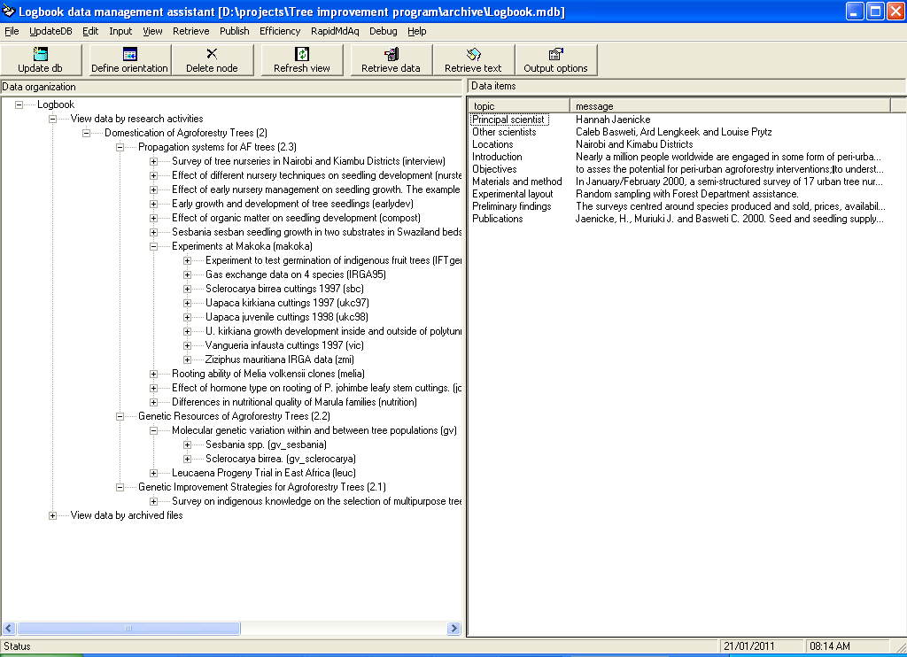

~\projects\Tree improvement program\archive\Logbook.mdb. The above figure represents tree view of the data organized by projects and experiments in the program. The right hand pane shows details of the research protocol. The correct version of the Logbook to view and retrieve these data is found at ~\Data management\policy\implementation\Websites\Project data curator\setup\publish\Support\lb.exe

## The East and Central Africa Regional Program

The data from this regional programmer was contributed by Bashir Jama, leader of the East and Central Africa Regional program, with assistance from Abedinego Kiwia and Anne Njui. It covers the period 2001-2008. The original files are found at ~\projects\ECA System\data; a catalog of the same data is available at ~\projects\ECA System\database\shell-project.mdb, organized under the headings shown in the tree view below.

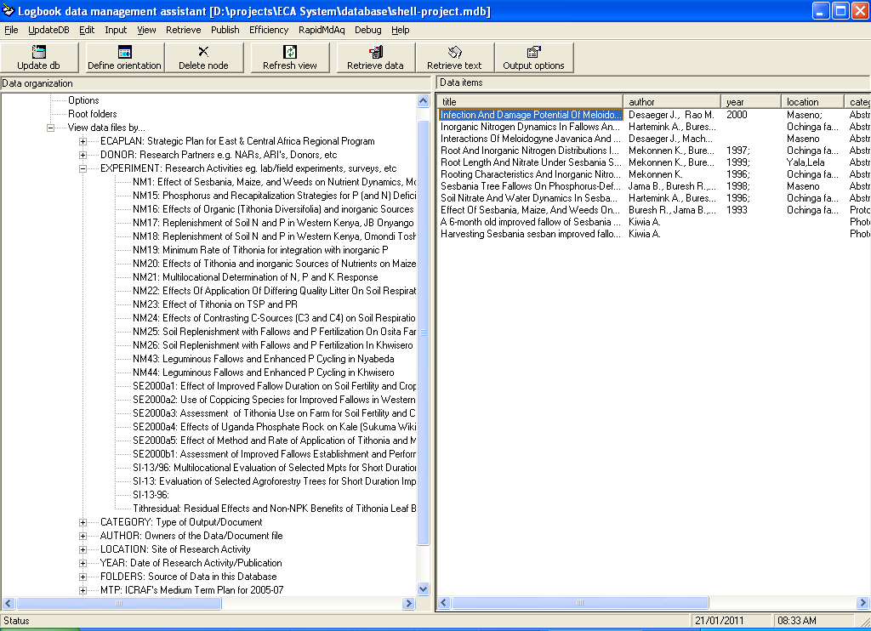

The right hand pane of the window lists the annotated files associated with the entry pointed at in the tree view.

## Alternatives to Slash and Burn in Forest Margins

Thomas P. Tomich, the former coordinator contributed this data in the form of country reports available at ~\projects\ASB\ASB Country and Thematic reports – xml. The Research Methods group turned the data into a browsable catalog accessible from a web site with this address ~\projects\ASB\Website\home.htm. The screen shot below shows the link to the datasets which were archived on a Microsoft Sharepoint server at the following address <http://icrafsharept.icraf.cgiar.org/Icraf/Documents/Research%20Data/Data%20by%20regions/ASB/Available%20datasets/browse.htm>. The last time I tried accessing this server indicated that it was unavailable

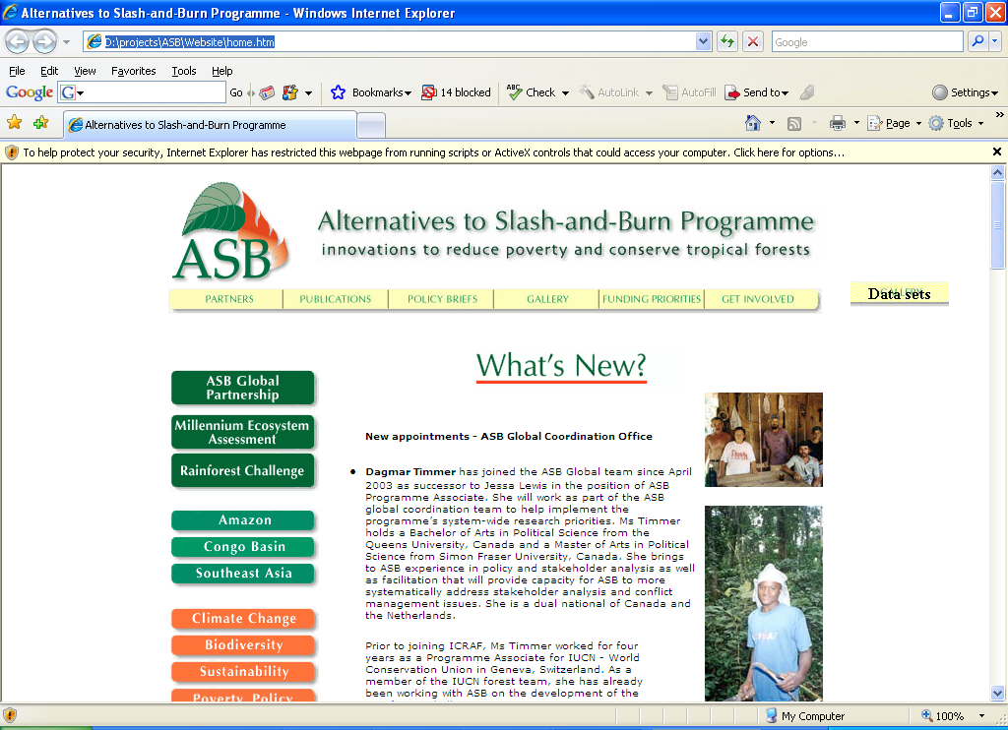

## Improved Fallows in Eastern Zambia

This data was contributed by Paramu Mafongoya, as part of his handover procedure. Most of it is from on-farm trials using improved fallows in the Chipata region of Eastern Zambia, lead by Fredie Kwesiga. These data were not annotated in any way; they are accessed in their original format from ~\projects\Chipata.

## Soil Nutrients Management

This data, available at ~\projects\Paul Smithson, represents over 10 years of data resulting from analyses of soil and plant samples in the ICRAF laboratory. Nine months before Paul Smithson left ICRAF, he was assisted by Andrew Sila to collate these data from various soil scientists, e.g. Rowland Buresh. Most of it was managed using a Laboratory Information Syetem that was based on the Logbook Toolbox; Valentine Karari was the data curator.

## Woodlots Research in Shinyanga, Tanzania

This data was contributed by Robert Otsyna, a former leader of ICRAF’s country program in Tanzania as part of his handover process. The original data file is found in ~\projects\Shinyanga data rescue. During the handover, RMG assisted the data originators to quickly put together a data navigation catalogue, available at ~\projects\Shinyanga data rescue\1TABLE OF CONTENTS\Table of contents 2000.mdb

## Lake Victoria Land Management Project

Chin Ong and his colleagues in the Transvic project contributed these data; it is saved in ~\projects\TransVic\Datasets by holder. An annotated version of the same data was accessible from the Transvic website, saved at ~\projects\TransVic\Website\index.htm, using the Publications link.

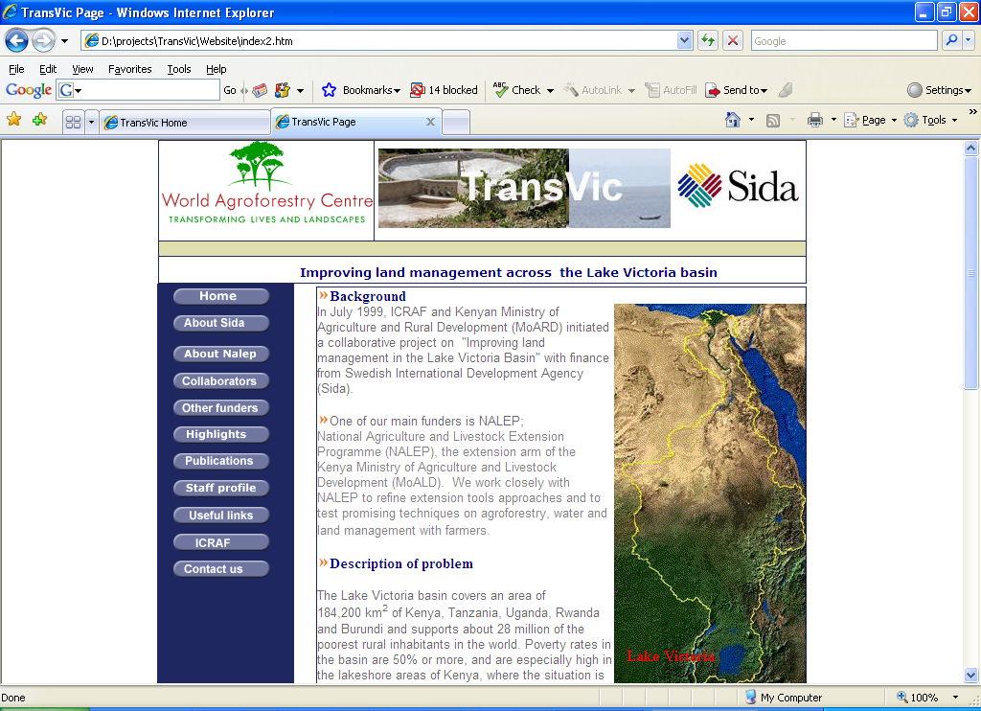

The Publications link pointed to the annotated data, via the page shown below; the data was 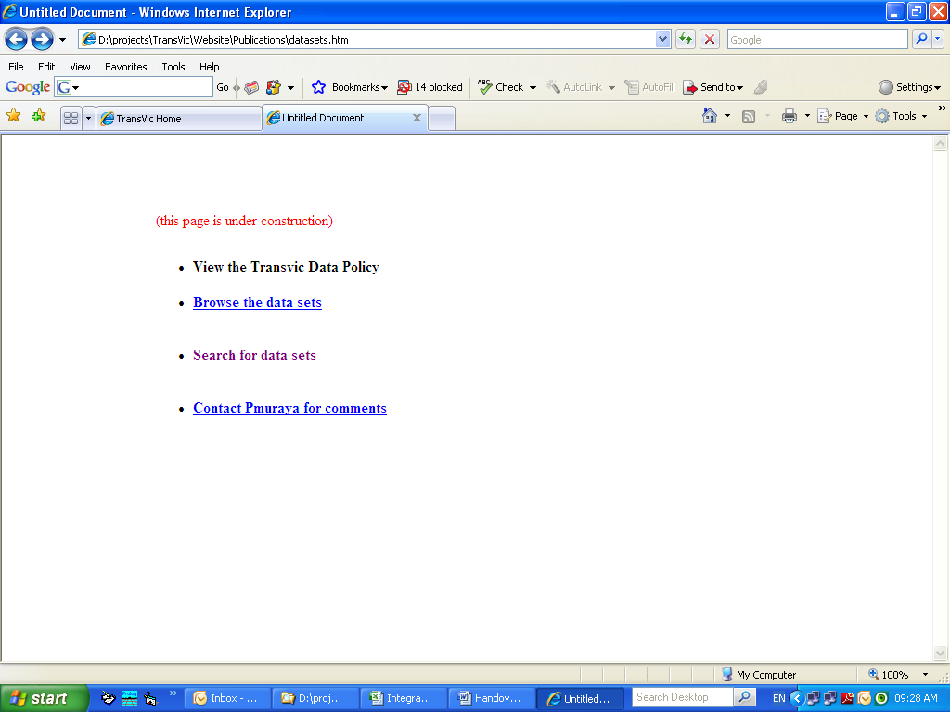

archived in the ICRAF’s Microsoft Sharepoint server at this address http://icrafsharept.icraf.cgiar.org/icraf/Documents/Research%20Data/Search%20for%20data/ASearch_Client.asp?project=TransVic

## Southern Africa Regional Program

Most of the data archived under this program was Agroforestry options dissemination work conducted in Malawi by Andreas Boringer and his team. The original data is in ~\projects\Zambezi river basin\Available data; a browsable version is accessed from ~\projects\Zambezi river basin\Required data1\browse.htm. See the screen shot below.

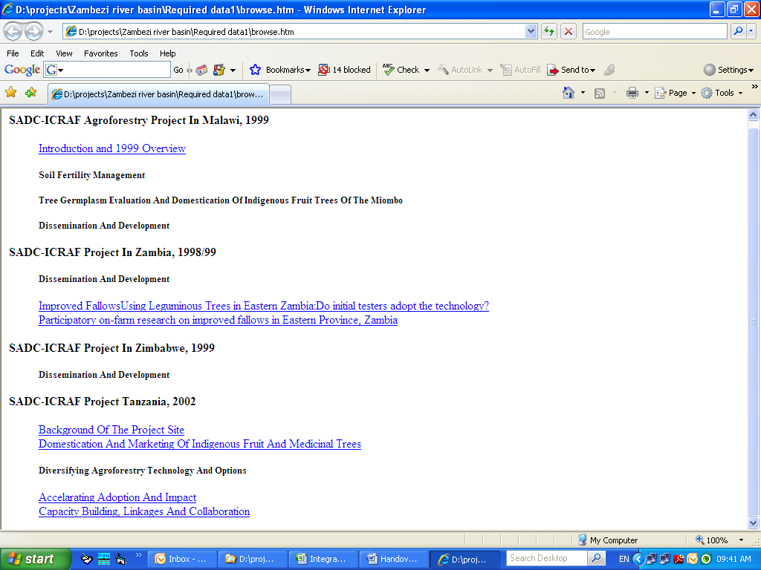

## Western Kenya Integrated Ecosystem Project

After most of the researchers in this project had left ICRAF, the Research Methods Group was contracted to assemble data from this project to feed into the Carbon Benefits Project.

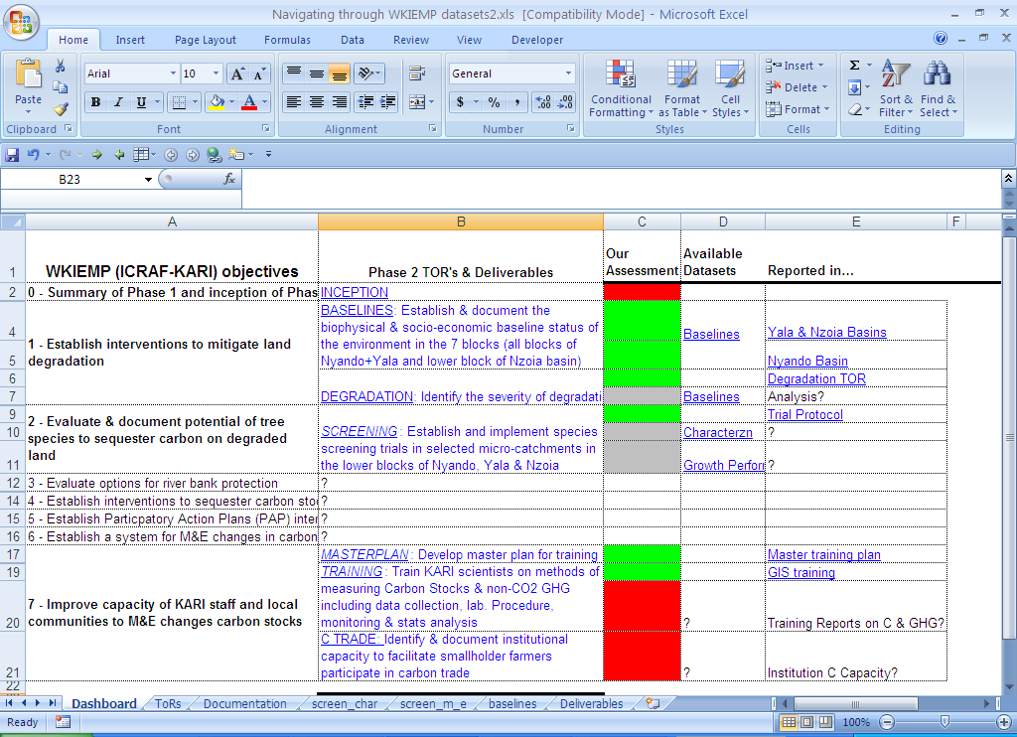

The original data is saved in an ICRAF ftp site that was later cleaned by the ICT team without consultations with the Research Methods Group. A backup version is available from the Shared server through a dashboard similar to the one above. It was designed to match the terms of reference between ICRAF and the Kenya Agricultural Research Institute that contracted this work to ICRAF. The red boxes indicate areas for which no data to support those TORs was available.

# The Logbook Toolbox

The Logbook Toolbox is a collection of data management tools that have been developed by the author with assistance from many students attached to the Research Methods Group and under his supervision. It represents 15 years of software development to support different data management needs that arose following ad hoc support many research projects. The section points to the location of the Logbook Toolbox binary code, source code and associated documentation. A complete documentation of the toolkit is beyond the scope of this handover report

## Binary code

The last version of toolkit was compiled on 13/01/2010, and is available at ~\Logbook\distribution\Latest_version. Run the setup.exe to install the toolkit on a new computer. The toolkit has been tested on Windows XP and Microsoft Office 2003 and 2007. A successful installation will create this executable file, ~\Logbook\bin\lb.exe, supported by the following two dynamic link libraries.

* ~\Logbook\bin\POPULATE.DLL
* ~\Logbook\bin\dao.dll

## Source code

The source code for the toolkit appears in 3 languages: Basic, Prolog and C++

**Visual Basic (VB)**

This programming language was used to develop the user interface of the toolkit. The VB project is available at ~\Logbook\code\user\explorer\Logbook.vbp

**PDC Visual Prolog**

This programming language, version 5.0 for Windows 32, was used to develop the complex logic behind the data transfer processor of the toolkit. The Prolog project is available at ~\Logbook\code\populate\POPULATE.VPR

**Microsoft C++**

Microsoft Visual C++ 6.0 was used to interface the prolog code to Microsoft’s data Access objects, thus allowing read/write requests to a Microsoft Access 2003 access database. The C++ project is available at ~\Logbook\code\dao\dao.sln

In addition to source code for the programming languages, the author developed other codes to support the toolkit. These were XML schema, saved in ~\Logbook\xml schemas. One of the important schema is ~\Logbook\xml schemas\questionnaire.xsd; it was the innovation behind the Quefax method described in 2.2.1 and the smart forms in the Carbon Benefits Project. The Quefax method also relies on the following two XML Stylesheets:-

* ~\Logbook\xml schemas\schema.xslt, for extracting database structure from electronic forms (e-forms)
* ~\Logbook\xml schemas\data.xslt, for transferring data from e-forms to a database

## Documentation

The Logbook toolkit is extensively documented, but most of it is internal. This means that the documentation is done as part of the source code, in what programmers refer to as comments, as shown by the green colored statements in the figure below.

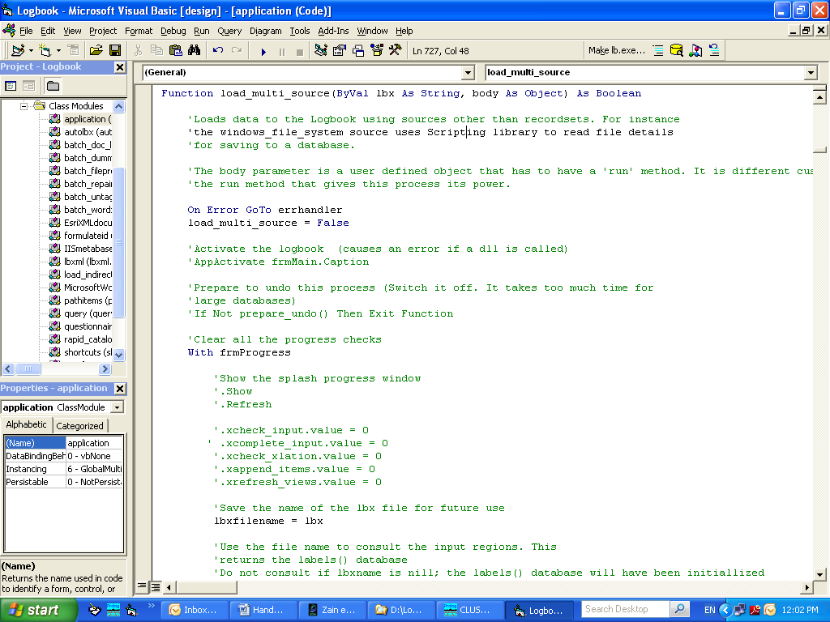

This level of documentation is more useful to programmers intending to expand the toolkit than to end users who are more interested in higher level applications. The author has not been motivated to do l document the toolkit outside of the source code, until now. But that is outside the scope of this handover report. In this section, I will point to locations where interested users may get insights into the range of functions of the toolkit. These are locations containing samples of datasets, worksheet templates, power point presentations and documentation developed for application built with Logbook.

**Samples**

There are:-

* Sample datasets prepared following the Logbook protocol available at ~\Logbook\sample data for Logbook-activity.
* Sample data models available at ~\Logbook\data models
* Sample worksheet templates at ~\Logbook\code\templates

**Applications**

These are some of the documented applications based on the Logbook

|  |  |  |
| --- | --- | --- |
| Application | Description | Documentation |
| Quefax | Smart forms for data acquisition | see section 2.2.1 |
| Climsoft | Climatic Data Management System for small Meteorological centers, | ~\projects\Climsoft\clicom project\User Guide.doc |
| Banana Logbook | Data Management system for the Banana Research Program in Uganda | ~\Logbook\doc\manual\Uganda version\Full Manual.doc |
| Data Publisher | Publishing data on a local intranet | ~\projects\Cathy Garlick\DP Users Manual 07-02-13.doc, ~\projects\Cathy Garlick\DP Getting Started Guide.doc |
| LabInfo | Laboratory Information System | ?? |

Presentations

There are more presentations than is possible to document in the time frame available for this report. A quick search using the Logbook keyword reveals 98 power point files. Some of these hits are more useful than others; it will take more time to find out which ones are.

# Appendices

## Baseline Databases for the SSA-CP

| **SSA-CP baseline databases** | | | | | | | |
| --- | --- | --- | --- | --- | --- | --- | --- |
| **Site** | **TaskForce** | **Stratum** | **Region** | **Date** | **Qualifier** | **Provider** | **Folder** |
| KKM | NGS | Household | Katsina-Nigeria | 01/04/2010 |  | Kajang | ~\projects\ssa cp\Datasets\Databases_V2\KKM\Kajang\NGS Household.mdb |
| KKM | NGS | Household | Katsina-Nigeria | 17/05/2010 |  | Luke | ~\projects\ssa cp\Datasets\Cleaned data - 2010-05-18-ILRI\CURRENT KKM CLEAN\NGS Current Cleaned Databases\NGS Household Database.mdb |
| KKM | NGS | Plot | Katsina-Nigeria | 01/04/2010 |  | Kajang | ~\projects\ssa cp\Datasets\Databases_V2\KKM\Kajang\NGS Plot level.mdb |
| KKM | NGS | plot | Katsina-Nigeria | 17/05/2010 |  | Luke | ~\projects\ssa cp\Datasets\Cleaned data - 2010-05-18-ILRI\CURRENT KKM CLEAN\NGS Current Cleaned Databases\NGS Plot level Database.mdb |
| KKM | NGS | village | Katsina-Nigeria | 01/04/2010 |  | Kajang | ~\projects\ssa cp\Datasets\Databases_V2\KKM\Kajang\NGS Village Characterization.mdb |
| KKM | NGS | village | Katsina-Nigeria | 17/05/2010 |  | Luke | ~\projects\ssa cp\Datasets\Cleaned data - 2010-05-18-ILRI\CURRENT KKM CLEAN\NGS Current Cleaned Databases\NGS Village Database.mdb |
| KKM | SaS | household | Niger | 01/04/2010 |  | Lawali | ~\projects\ssa cp\Datasets\Databases_V2\KKM\Lawali\Household Survey.mdb |
| KKM | SaS | household | Niger | 17/05/2010 |  | Luke | ~\projects\ssa cp\Datasets\Cleaned data - 2010-05-18-ILRI\CURRENT KKM CLEAN\SaS DataBase Cleaned\Household Survey 7 May 10.mdb |
| KKM | SaS | plot | Niger | 01/04/2010 | 2 | Lawali | ~\projects\ssa cp\Datasets from Jemima as cleaned\SahelBase Line\Distribution\datasets\Sahel Savannah\Plot level\plot level_2\Plot level 7 Aug 09.mdb |
| KKM | SaS | plot | Niger | 01/04/2010 | 1 | Lawali | ~\projects\ssa cp\Datasets from Jemima as cleaned\SahelBase Line\Distribution\datasets\Sahel Savannah\Plot level\plot level_1\Plot level 7 Aug 09.mdb |
| KKM | SaS | plot | Niger | 17/05/2010 | 1+2 | Luke | ~\projects\ssa cp\Datasets\Cleaned data - 2010-05-18-ILRI\CURRENT KKM CLEAN\SaS DataBase Cleaned\Sahel Plot level.mdb |
| KKM | SaS | village | Niger | 01/04/2010 |  | Lawali | ~\projects\ssa cp\Datasets\Databases_V2\KKM\Lawali\Village Characterization.mdb |
| KKM | SaS | village | Niger | 17/05/2010 |  | Luke | ~\projects\ssa cp\Datasets\Cleaned data - 2010-05-18-ILRI\CURRENT KKM CLEAN\SaS DataBase Cleaned\Village Characterization 7 Aug 09.mdb |
| KKM | SuS | household | Kano-Nigeria | 01/04/2010 |  | Yemisi | ~\projects\ssa cp\Datasets\Databases_V2\KKM\Yemisi\Household Survey.mdb |
| KKM | SUS | household | Kano-Nigeria | 17/05/2010 |  | Luke | ~\projects\ssa cp\Datasets\Cleaned data - 2010-05-18-ILRI\CURRENT KKM CLEAN\Sudan Savanna current clean\Household Survey 7 Aug 09.mdb |
| KKM | SuS | ip | Kano-Nigeria | 01/04/2010 |  | Yemisi | ~\projects\ssa cp\Datasets\Oluwayemisi ADEDIPE\IP Characterization\dbase\IP site characterization.mdb |
| KKM | SuS | plot | Kano-Nigeria | 01/04/2010 |  | Yemisi | ~\projects\ssa cp\Datasets\Oluwayemisi ADEDIPE\Plot Level\dbase\Plot level.mdb |
| KKM | SuS | plot | Kano-Nigeria | 17/05/2010 |  | Luke | ~\projects\ssa cp\Datasets\Cleaned data - 2010-05-18-ILRI\CURRENT KKM CLEAN\Sudan Savanna current clean\Plot level.mdb |
| KKM | SuS | village | Kano-Nigeria | 01/04/2010 |  | Yemisi | ~\projects\ssa cp\Datasets\Databases_V2\KKM\Yemisi\Village characterization.mdb |
| KKM | SuS | village | Kano-Nigeria | 17/05/2010 |  | Luke | ~\projects\ssa cp\Datasets\Cleaned data - 2010-05-18-ILRI\CURRENT KKM CLEAN\Sudan Savanna current clean\Village characterization 7 Aug 09.mdb |
| LK | markets | household | rwanda | 01/04/2010 | 08 | Judy | ~\projects\ssa cp\Datasets\Databases_V2\LK\Judy\Rwanda-2008.mdb |
| LK | markets | household | rwanda | 01/04/2010 | 09 | Judy | ~\projects\ssa cp\Datasets\Databases_V2\LK\Judy\Rwanda - 2009.mdb |
| LK | markets | household | rwanda | 17/05/2010 | 09 | Judith | ~\projects\ssa cp\Datasets\Cleaned data - 2010-05-18-ILRI\LK-Final datasets_May2010\Rwanda\Rwanda_HH_plot 2009_May082010.mdb |
| LK | Markets | household | Rwanda | 17/05/2010 | 08 | Judith | ~\projects\ssa cp\Datasets\Cleaned data - 2010-05-18-ILRI\LK-Final datasets_May2010\Rwanda\Rwanda_HH_plot 2008_May082010.mdb |
| LK | markets | ip | rwanda | 17/05/2010 |  | Judith | ~\projects\ssa cp\Datasets\Cleaned data - 2010-05-18-ILRI\LK-Final datasets_May2010\Rwanda\Stakeholder _Rwanda_May082010.mdb |
| LK | markets | trader | rwanda | 01/04/2010 | 08 | Wanjiku | ~\projects\ssa cp\Datasets\Wanjiku CHIURI\Market survey\dbase\trader survey.mdb |
| LK | markets | village | rwanda | 01/04/2010 | 08+9 | Claver | ~\projects\ssa cp\Datasets\Databases_V2\LK\Claver\Village characterization.mdb |
| LK | markets | village | rwanda | 17/05/2010 | 08+9 | Judith | ~\projects\ssa cp\Datasets\Cleaned data - 2010-05-18-ILRI\LK-Final datasets_May2010\Rwanda\Village_Rwanda_May082010.mdb |
| LK | nrm | household | ug | 01/04/2010 | 08+9 | Fungo | ~\projects\ssa cp\Datasets\Databases_V2\LK\Fungo\Uganda_Household and Plotlevel-fixed for HH.mdb |
| LK | NRM | household | Ug | 17/05/2010 | 08+9 | Judith | ~\projects\ssa cp\Datasets\Cleaned data - 2010-05-18-ILRI\LK-Final datasets_May2010\Uganda\Uganda_HH_Plot_May112010.mdb |
| LK | nrm | ip | ug | 01/04/2010 |  | Fungo | ~\projects\ssa cp\Datasets\Benard FUNGO\IP and Stakeholder Analysis\dbase\IP and Stakeholder Analysis.mdb |
| LK | nrm | ip | ug | 17/05/2010 |  | Judith | ~\projects\ssa cp\Datasets\Cleaned data - 2010-05-18-ILRI\LK-Final datasets_May2010\Uganda\Uganda_11May2010_Stakeholder.mdb |
| LK | nrm | plot | ug | 01/04/2010 | 08+9 | Fungo | ~\projects\ssa cp\Datasets\Databases_V2\LK\Fungo\Uganda_Household and Plotlevel-fixed for plots.mdb |
| LK | nrm | plot | ug | 17/05/2010 | 08+9 | Judith | ~\projects\ssa cp\Datasets\Cleaned data - 2010-05-18-ILRI\LK-Final datasets_May2010\Uganda\Uganda_HH_Plot_May112010.mdb |
| LK | nrm | village | ug | 01/04/2010 | 08 | Fungo | ~\projects\ssa cp\Datasets\Databases_V2\LK\Fungo\Fungo_Village characterization_old Ug sites.mdb |
| LK | nrm | village | ug | 01/04/2010 | 09 | Fungo | ~\projects\ssa cp\Datasets\Databases_V2\LK\Fungo\Fungo_Village characterization_UG new sites.mdb |
| LK | nrm | village | ug | 17/05/2010 | 08+9 | Judith | ~\projects\ssa cp\Datasets\Cleaned data - 2010-05-18-ILRI\LK-Final datasets_May2010\Uganda\Uganda_Village_May112010.mdb |
| LK | productivity | household | DRC | 01/04/2010 | 08 | Judy | ~\projects\ssa cp\Datasets\Databases_V2\LK\Judy\DRC 2008 combined.mdb |
| LK | productivity | household | DRC | 01/04/2010 | 09 | Fungo | ~\projects\ssa cp\Datasets\Databases_V2\LK\Fungo\DRC 2009 HH and PL.mdb |
| LK | productivity | household | DRC | 17/05/2010 | 08 | Judith | ~\projects\ssa cp\Datasets\Cleaned data - 2010-05-18-ILRI\LK-Final datasets_May2010\DRC\DRC 2008_HH_Plot_May082010.mdb |
| LK | productivity | household | DRC | 17/05/2010 | 09 | Judith | ~\projects\ssa cp\Datasets\Cleaned data - 2010-05-18-ILRI\LK-Final datasets_May2010\DRC\DRC 2009_HH_Plot_May082010.mdb |
| LK | productivity | ip | DRC | 17/05/2010 | 09 | Judith | ~\projects\ssa cp\Datasets\Cleaned data - 2010-05-18-ILRI\LK-Final datasets_May2010\DRC\DRC Stakeholder_2009.mdb |
| LK | productivity | ip | DRC | 17/05/2010 | 08 | Judith | ~\projects\ssa cp\Datasets\Cleaned data - 2010-05-18-ILRI\LK-Final datasets_May2010\DRC\DRC_Stakeholder_2008.mdb |
| LK | productivity | ip | rwanda | 01/04/2010 |  | Claver | ~\projects\ssa cp\Datasets\Claver NGABOYISONGA\Stakeholder Analysis\dbase\Stakeholder Analysis.mdb |
| LK | productivity | plot | DRC | 01/04/2010 | ? | Leblanc | ~\projects\ssa cp\Datasets\Leblanc BAHIGA\Plot level\dbase\Plot level.mdb |
| LK | productivity | plot | DRC | 17/05/2010 | 09 | Judith | ~\projects\ssa cp\Datasets\Cleaned data - 2010-05-18-ILRI\LK-Final datasets_May2010\DRC\DRC 2009_HH_plot_May082010.mdb |
| LK | Productivity | plot | DRC | 17/05/2010 | 08 | Judith | ~\projects\ssa cp\Datasets\Cleaned data - 2010-05-18-ILRI\LK-Final datasets_May2010\DRC\DRC 2008_HH_Plot_May082010.mdb |
| LK | productivity | village | DRC | 01/04/2010 | 08+9 | Leblanc | ~\projects\ssa cp\Datasets\Databases_V2\LK\Leblanc\DRC_Villages.mdb |
| LK | productivity | village | DRC | 17/05/2010 | 08+9 | Judith | ~\projects\ssa cp\Datasets\Cleaned data - 2010-05-18-ILRI\LK-Final datasets_May2010\DRC\DRC_Village_07052010.mdb |
| ZMM | CA | household | malawi | 01/04/2010 |  | Bella | ~\projects\ssa cp\Datasets\Databases_V2\ZMM\Bella\CA-Mal-HH.mdb |
| ZMM | CA | household | malawi | 17/05/2010 |  | Kefasi | ~\projects\ssa cp\Datasets\Cleaned data - 2010-05-18-ILRI\FARA ZMM DATA clean\CIAT\Malawi\CA-Malawi-HH.mdb |
| ZMM | CA | household | moz | 01/04/2010 |  | Bella | ~\projects\ssa cp\Datasets\Databases_V2\ZMM\Bella\CA-Moz_households.mdb |
| ZMM | CA | household | moz | 17/05/2010 |  | Kefasi | ~\projects\ssa cp\Datasets\Cleaned data - 2010-05-18-ILRI\FARA ZMM DATA clean\CIAT\Mozambique\Household Mozambiquedbase.mdb |
| ZMM | CA | household | zim | 01/04/2010 |  | Bella | ~\projects\ssa cp\Datasets\Databases_V2\ZMM\Bella\CA-Zim-Household.mdb |
| ZMM | CA | household | zim | 17/05/2010 |  | Kefasi | ~\projects\ssa cp\Datasets\Cleaned data - 2010-05-18-ILRI\FARA ZMM DATA clean\CIAT\Zimbabwe\CA Zimbabwe Household cleaned.mdb |
| ZMM | CA | household_ca | malawi | 01/04/2010 |  | Bella | ~\projects\ssa cp\Datasets\Databases_V2\ZMM\Bella\CA-Mal-TF Specific.mdb |
| ZMM | CA | household_ca | malawi | 17/05/2010 |  | Kefasi | ~\projects\ssa cp\Datasets\Cleaned data - 2010-05-18-ILRI\FARA ZMM DATA clean\CIAT\Malawi\Malawi TF Specific Template.mdb |
| ZMM | CA | household_ca | moz | 01/04/2010 |  | Bella | ~\projects\ssa cp\Datasets\Databases_V2\ZMM\Bella\CA-Moz-TFspecific.mdb |
| ZMM | CA | household_ca | moz | 17/05/2010 |  | Kefasi | ~\projects\ssa cp\Datasets\Cleaned data - 2010-05-18-ILRI\FARA ZMM DATA clean\CIAT\Mozambique\CA-Mozambigue-TFspecific.mdb |
| ZMM | CA | household_ca | zim | 01/04/2010 |  | Bella | ~\projects\ssa cp\Datasets\Databases_V2\ZMM\Bella\CA-Zimbabwe-TFspecific.mdb |
| ZMM | CA | household_ca | Zim | 17/05/2010 |  | Kefasi | ~\projects\ssa cp\Datasets\Cleaned data - 2010-05-18-ILRI\FARA ZMM DATA clean\CIAT\Zimbabwe\CA-Zimbabwe-TFspecific.mdb |
| ZMM | CA | plot | malawi | 01/04/2010 |  | Bella | ~\projects\ssa cp\Datasets\Databases_V2\ZMM\Bella\CA-Mal-Plots.mdb |
| ZMM | CA | plot | malawi | 17/05/2010 |  | Kefasi | ~\projects\ssa cp\Datasets\Cleaned data - 2010-05-18-ILRI\FARA ZMM DATA clean\CIAT\Malawi\CA-Malawi-Plots.mdb |
| ZMM | CA | plot | moz | 01/04/2010 |  | Bella | ~\projects\ssa cp\Datasets\Databases_V2\ZMM\Bella\CA-Moz-Plots.mdb |
| ZMM | CA | plot | moz | 17/05/2010 |  | Kefasi | ~\projects\ssa cp\Datasets\Cleaned data - 2010-05-18-ILRI\FARA ZMM DATA clean\CIAT\Mozambique\CA-Moz-Plots.mdb |
| ZMM | CA | plot | zim | 01/04/2010 |  | Bella | ~\projects\ssa cp\Datasets\Databases_V2\ZMM\Bella\CA-Zim-Plots.mdb |
| ZMM | CA | plot | zim | 17/05/2010 |  | Kefasi | ~\projects\ssa cp\Datasets\Cleaned data - 2010-05-18-ILRI\FARA ZMM DATA clean\CIAT\Zimbabwe\CA-ZIMBAWE-Plots unclean.mdb |
| ZMM | CA | village | malawi | 01/04/2010 |  | Bella | ~\projects\ssa cp\Datasets\Databases_V2\ZMM\Bella\CA-Mal-Village characterization.mdb |
| ZMM | CA | village | malawi | 17/05/2010 |  | Kefasi | ~\projects\ssa cp\Datasets\Cleaned data - 2010-05-18-ILRI\FARA ZMM DATA clean\CIAT\Malawi\CA-Malawi-Village characterization.mdb |
| ZMM | CA | village | moz | 01/04/2010 |  | Bella | ~\projects\ssa cp\Datasets\Databases_V2\ZMM\Bella\CA-Moz-village characterization.mdb |
| ZMM | CA | village | moz | 17/05/2010 |  | Kefasi | ~\projects\ssa cp\Datasets\Cleaned data - 2010-05-18-ILRI\FARA ZMM DATA clean\CIAT\Mozambique\CA_Moz_village characterization.mdb |
| ZMM | CA | village | zim | 01/04/2010 |  | Bella | ~\projects\ssa cp\Datasets\Databases_V2\ZMM\Bella\CA-Zim-Village characterization.mdb |
| ZMM | CA | village | zim | 17/05/2010 |  | Kefasi | ~\projects\ssa cp\Datasets\Cleaned data - 2010-05-18-ILRI\FARA ZMM DATA clean\CIAT\Zimbabwe\Zimbabwe Village Characterisation.mdb |
| ZMM | SOFECSA | household | malawi | 01/04/2010 |  | Byron | ~\projects\ssa cp\Datasets\Byron ZAMASIYA\Edited Soil Fertility TF\malawi\Household survey\Edited-Household survey_soil TF Malawi.mdb |
| ZMM | SOFECSA | household | malawi | 17/05/2010 |  | Kefasi | ~\projects\ssa cp\Datasets\Cleaned data - 2010-05-18-ILRI\FARA ZMM DATA clean\SOFESCA\Malawi\Cleaned Household survey_soils Malawi.mdb |
| ZMM | SOFECSA | household | moz | 01/04/2010 |  | Byron | ~\projects\ssa cp\Datasets\Byron ZAMASIYA\Edited Soil Fertility TF\Moz\households\dbase\Edited-household survey-soil TF Mozambique.mdb |
| ZMM | SOFECSA | household | moz | 17/05/2010 |  | Kefasi | ~\projects\ssa cp\Datasets\Cleaned data - 2010-05-18-ILRI\FARA ZMM DATA clean\SOFESCA\mozambique baseline\household survey-soil TF Mozambique.mdb |
| ZMM | SOFECSA | household | zim | 01/04/2010 |  | Byron | ~\projects\ssa cp\Datasets\Databases_V2\ZMM\Byron\Household survey-Soil TF-Zimbabwe.mdb |
| ZMM | SOFECSA | household | zim | 17/05/2010 |  | Kefasi | ~\projects\ssa cp\Datasets\Cleaned data - 2010-05-18-ILRI\FARA ZMM DATA clean\SOFESCA\zimbabwe soils fara baseline\Household survey-Soil TF-Zimbabwe.mdb |
| ZMM | SOFECSA | plot | malawi | 01/04/2010 |  | Byron | ~\projects\ssa cp\Datasets\Databases_V2\ZMM\Byron\zmm-sofecsa-malawi-plot.mdb |
| ZMM | SOFECSA | plot | malawi | 17/05/2010 |  | Kefasi | ~\projects\ssa cp\Datasets\Cleaned data - 2010-05-18-ILRI\FARA ZMM DATA clean\SOFESCA\zimbabwe soils fara baseline\malawi-zim soil Plot level soils.mdb |
| ZMM | SOFECSA | plot | moz | 01/04/2010 |  | Byron | ~\projects\ssa cp\Datasets\Byron ZAMASIYA\Edited Soil Fertility TF\Moz\plot level\dbase\SF_Moz_Plot.mdb |
| ZMM | SOFECSA | plot | moz | 17/05/2010 |  | Kefasi | ~\projects\ssa cp\Datasets\Cleaned data - 2010-05-18-ILRI\FARA ZMM DATA clean\SOFESCA\mozambique baseline\Mozambique_Plot levels soils.mdb |
| ZMM | SOFECSA | plot | zim | 01/04/2010 |  | Byron | ~\projects\ssa cp\Datasets\Databases_V2\ZMM\Byron\zmm-sofecsa-zim-plot.mdb |
| ZMM | SOFECSA | plot | zim | 17/05/2010 |  | Kefasi | ~\projects\ssa cp\Datasets\Cleaned data - 2010-05-18-ILRI\FARA ZMM DATA clean\SOFESCA\zimbabwe soils fara baseline\malawi-zim soil Plot level soils.mdb |
| ZMM | SOFECSA | village | malawi | 01/04/2010 |  | Byron | ~\projects\ssa cp\Datasets\Byron ZAMASIYA\Edited Soil Fertility TF\malawi\Village characterization\Edited-malawi-Village Characterization_Soil TF.mdb |
| ZMM | Sofecsa | village | malawi | 17/05/2010 |  | Kefasi | ~\projects\ssa cp\Datasets\Cleaned data - 2010-05-18-ILRI\FARA ZMM DATA clean\SOFESCA\Malawi\malawi-Village Characterization_soils.mdb |
| ZMM | SOFECSA | village | moz | 01/04/2010 |  | Byron | ~\projects\ssa cp\Datasets\Byron ZAMASIYA\Edited Soil Fertility TF\Moz\village characterization\dbase\edited-mozambique -soil tf-village characterization.mdb |
| ZMM | SOFECSA | village | moz | 17/05/2010 |  | Kefasi | ~\projects\ssa cp\Datasets\Cleaned data - 2010-05-18-ILRI\FARA ZMM DATA clean\SOFESCA\mozambique baseline\mozambique village characterization soils.mdb |
| ZMM | SOFECSA | village | zim | 01/04/2010 |  | Byron | ~\projects\ssa cp\Datasets\Databases_V2\ZMM\Byron\Zim-Village Characterization soils.mdb |
| ZMM | SOFECSA | village | zim | 17/05/2010 |  | Kefasi | ~\projects\ssa cp\Datasets\Cleaned data - 2010-05-18-ILRI\FARA ZMM DATA clean\SOFESCA\zimbabwe soils fara baseline\Zim-Village Characterization soils.mdb |
| ZMM | Vegetable | household | malawi | 01/04/2010 | clean | Malidadi | ~\projects\ssa cp\Datasets\Charles MALIDADI\cleaned db\Merged mal hh\Household survey-clean.mdb |
| ZMM | Vegetable | household | malawi | 01/04/2010 | ip | Malidadi | ~\projects\ssa cp\Datasets\Charles MALIDADI\cleaned db\Merged mal hh\Household survey-ip_convetional.mdb |
| ZMM | Vegetable | household | malawi | 17/05/2010 |  | Kefasi | ~\projects\ssa cp\Datasets\Cleaned data - 2010-05-18-ILRI\FARA ZMM DATA clean\BIOVERSITY\Malawi\cleaned Household survey malawi.mdb |
| ZMM | Vegetable | household | moz | 01/04/2010 | zambezia | Maria | ~\projects\ssa cp\Datasets\Charles MALIDADI\cleaned db\Moz data\HH survey_zambezia.mdb |
| ZMM | Vegetable | household | moz | 01/04/2010 | manica | Maria | ~\projects\ssa cp\Datasets\Charles MALIDADI\cleaned db\Moz data\HH survey_manica.mdb |
| ZMM | Vegetable | household | moz | 17/05/2010 |  | Kefasi | ~\projects\ssa cp\Datasets\Cleaned data - 2010-05-18-ILRI\FARA ZMM DATA clean\BIOVERSITY\Mozambique\Mozambique HH survey_Vegetable.mdb |
| ZMM | Vegetable | household | Moz | 17/05/2010 | milage | Kefasi | ~\projects\ssa cp\Datasets\Cleaned data - 2010-05-18-ILRI\FARA ZMM DATA clean\BIOVERSITY\Mozambique\Veg household Milage clean1.mdb |
| ZMM | Vegetable | household_nutrition | malawi | 01/04/2010 |  | Malidadi | ~\projects\ssa cp\Datasets\Charles MALIDADI\Veg Malawi\Vegetable survey\dbase\Veg survey.mdb |
| ZMM | Vegetable | household_vegetables | moz | 01/04/2010 |  | Maria | ~\projects\ssa cp\Datasets\Charles MALIDADI\Veg Mozambique\vegetable_zambezia\dbase\Vegetable zambezia.mdb |
| ZMM | Vegetable | ip | malawi | 01/04/2010 |  | Malidadi | ~\projects\ssa cp\Datasets\Charles MALIDADI\Veg Malawi\IP Characterization\dbase\IP Characterization.mdb |
| ZMM | Vegetable | ip | moz | 01/04/2010 |  | Maria | ~\projects\ssa cp\Datasets\Charles MALIDADI\Veg Mozambique\IP Characterization\dbase\IP Characterization.mdb |
| ZMM | Vegetable | plot | malawi | 01/04/2010 |  | Malidadi | ~\projects\ssa cp\Datasets\Charles MALIDADI\Veg Malawi\Plot level survey\dbase\plotlevel.mdb |
| ZMM | Vegetable | plot | malawi | 01/04/2010 | mulanje | Malidadi | ~\projects\ssa cp\Datasets\Charles MALIDADI\Veg Malawi\plotlevel_mulanje\dbase\plotlevel_mulanje.mdb |
| ZMM | Vegetable | plot | Malawi | 17/05/2010 |  | Kefasi | ~\projects\ssa cp\Datasets\Cleaned data - 2010-05-18-ILRI\FARA ZMM DATA clean\BIOVERSITY\Malawi\malawi-vegetables-plots.mdb |
| ZMM | Vegetable | plot | moz | 01/04/2010 |  | Maria | ~\projects\ssa cp\Datasets\Charles MALIDADI\Veg Mozambique\plot level_zambezia\dbase\Plot level.mdb |
| ZMM | Vegetable | village | malawi | 01/04/2010 |  | Malidadi | ~\projects\ssa cp\Datasets\Charles MALIDADI\Veg Malawi\Village characterization\dbase\village characterization.mdb |
| ZMM | Vegetable | village | moz | 01/04/2010 |  | Malidadi | ~\projects\ssa cp\Datasets\Charles MALIDADI\cleaned db\Moz data\village characterization.mdb |
| ZMM | Vegetable | village | moz | 17/05/2010 |  | Kefasi | ~\projects\ssa cp\Datasets\Cleaned data - 2010-05-18-ILRI\FARA ZMM DATA clean\BIOVERSITY\Mozambique\village characterization.mdb |